**Lab 3**

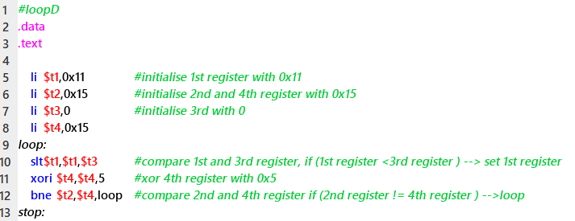

Figure 1: Program A

Table 1: Control signals for Pipelined Processor



F0630

Figure 2: Pipelined Processor

1. Copy Table 1 and add another row for I-type instruction. Fill in the relevant values.
2. Based on Program A, draw the instruction-time diagram.

|  |  |  |  |  |  |  |  |  |  |  |  |  |  |  |
| --- | --- | --- | --- | --- | --- | --- | --- | --- | --- | --- | --- | --- | --- | --- |
|  | **C1** | **C2** | **C3** | **C4** | **C5** | **C6** | **C7** | **C8** | **C9** | **C10** | **C11** | **C12** | **C13** | **C14** |
| li | IF | ID | EX | MEM | WB |  |  |  |  |  |  |  |  |  |
| li |  |  |  |  |  |  |  |  |  |  |  |  |  |  |
| li |  |  |  |  |  |  |  |  |  |  |  |  |  |  |
| li |  |  |  |  |  |  |  |  |  |  |  |  |  |  |
| slt |  |  |  |  |  |  |  |  |  |  |  |  |  |  |
| xor |  |  |  |  |  |  |  |  |  |  |  |  |  |  |
| bne |  |  |  |  |  |  |  |  |  |  |  |  |  |  |
| slt |  |  |  |  |  |  |  |  |  |  |  |  |  |  |
| xor |  |  |  |  |  |  |  |  |  |  |  |  |  |  |
| bne |  |  |  |  |  |  |  |  |  |  |  |  |  |  |

1. Copy Figure 2 (right-click ->Copy Image) to Jamboard/Paint or any image editing software. Using the image editing software, (assuming there is no hazard) draw the datapath and write the control values **for Cycle 7**. Draw the datapath using the Yellow Highlighter, and write ALL the control values using Blue Pen or sticky notes. Please remember to label (using sticky notes) by writing the instruction at its respective stage. Then submit your answer in a PDF file.